CIVITAS Unveils New Branding and Website in Honor of 35 Years
Denver-based design firm conjures fresh messaging to match real-world impact
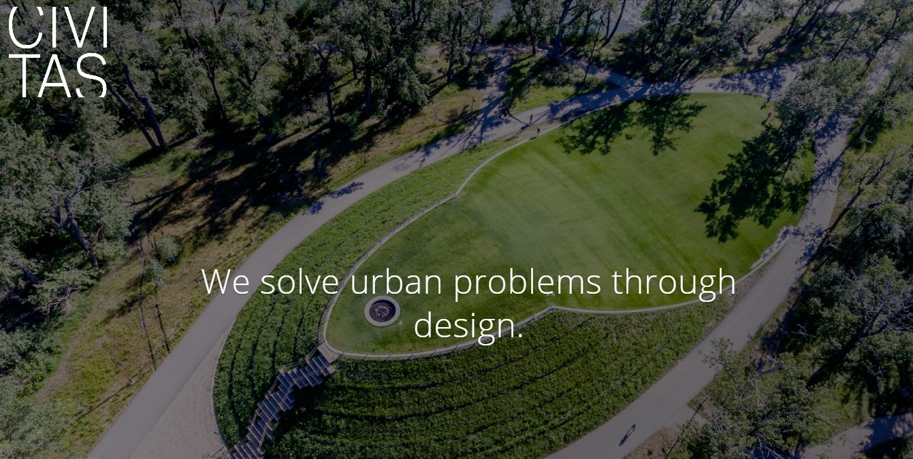
Known for its transformative urban projects worldwide, Civitas has launched new branding and a refreshed website to express its unique culture and approach.
Denver, Colorado – January 30, 2019 – For award-winning Denver urban design and landscape architecture firm Civitas, creating a new website and logo was more than adding better functionality and some new bells and whistles. Coming at the 35th anniversary of the firm that has for decades staked its reputation on being driven by an insatiable curiosity and future-looking approach to an ever-evolving world, Civitas embraced the chore as an opportunity to go deeper. Using the 35-year mark as a pivot, the team came together to identify and express a philosophy of practice rather than merely showcase its admittedly remarkable oeuvre of urban strategies, plans and projects undertaken across the U.S. and around the world.
“New urban landscapes have a new burden,” reads the new homepage manifesto, “—to heal scars, reclaim lost places, connect old and new systems, create cultural and economic value, attract people, activate neighborhoods and connect people to each other and the place they call home.” Always, Civitas’ role has been an active response that creates healthy public spaces that engage the “civitas” socially and answer environmental challenges even as they invite joy in those who experience them. The unveiling of the firm’s new branding and website clarifies the underlying missions.
“The new website represents our first attempt to express our thinking, values and purpose rather than just showing artifacts,” says founding principal Mark Johnson. “We’ve been talking about our company recently as a ‘35-year-old startup.’ For being 35 years old we’re really fresh. And that’s by intention. We’re deeply curious about how the world is changing and want to contribute to that change.”

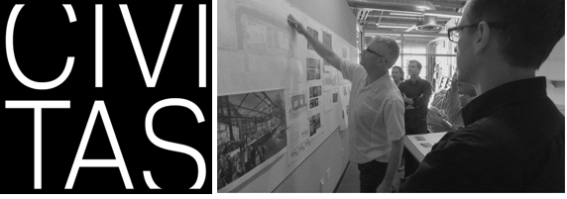
New Civitas logo, left, hints at “outside the box” thinking while helping the uninitiated with pronunciation. Right, “Civitots” at work in their Denver Golden Triangle office.
Leading the charge on the quest for greater clarity was new Civitas Director of Marketing Blake Booth Jordan, returned after a 10-year hiatus, although, she notes, she never really left, having often pitched in on a consulting basis when the firm was in a pinch. “I was able to walk in with fresh eyes and a deep understanding of what makes this firm so damn special – and it’s always been the people,” Jordan says.
“We pride ourselves on how unique we are, how quirky and how out of the ordinary – or should I say ‘outside of the box’ – we think,” she explains, with a reference to the company’s new square logo that doesn’t quite manage to box an expansive Civitas name, which pushes the boundaries, hinting at how much is yet left to be revealed. “That complex element has shaped some of the most intricate projects across the nation and we do it with genuine humility and without a sweeping signature, led by some of the industry’s best thinker-uppers who have been creatively solving problems for decades.”
Civitas Director of Marketing Blake Jordan, left. Awards for Civitas’ successful “nature in the city” approach at Calgary St. Patrick’s Island Park, right, include being named Canada’s “Great Public Space.”
She acknowledges the Civitas mystique is “certainly not an easy thing to ‘brand,’ but it was clear we needed to take a hard look at our messaging and rethink our dated website.” And her role as a “Civitot” – as the firm calls its people – allowed her to guide the process from the inside out, including tapping Denver web design boutique (in)spiregraphics to collaborate. They “studied us in our native habitat,” she says. “Their immediate absorption into our culture sealed the deal, helping them capture the essence of what makes us unique and craft it in a fresh and compelling way.”
Gaining full participation and consensus from Civitas’ principals, Mark Johnson, Scott Jordan, Chris Parezo and Craig Vickers, on the refresh is one of the things Blake Jordan is most proud of. “The results speak for themselves,” she says. “Our new aesthetic aligns beautifully with our firm culture, the logo is a creative spin on an often phonetically-challenged name and the new branding platform is the solid launching pad for the next 35 years.”
About Civitas:
Founded in 1984 with the core purpose of “creating healthier cities,” Denver-based Civitas, Inc., is an idea-based practice of urban designers, architects and landscape architects engaged in strategic planning for urban change and project design for built works. Recent honors received include both the 2017 International Architecture Award and 2018 American Architecture Award from the Chicago Athenaeum/European Centre; the Canadian Institute of Planners “Great Public Space”; a 2017 IMCL Merit Award; and an Excellence on the Waterfront Award from the nonprofit Waterfront Center. A consultancy and a design studio, Civitas advises on a wide range of strategies for re-imagining urban life and places, working in U.S. cities coast to coast and around the world. For additional information visit civitasinc.com.
Media contacts: Blake Booth Jordan, Civitas, bjordan@civitasinc.com, 303.571.0053; Anne McGregor Parsons, Word PR + Marketing, anne@wordprmarketing.com, 307.734.5335
###

